**A Project Report**

**On**

**Online Crime Reporting System**

Submitted in partial fulfilment of the requirements for the award of degree of

**Master Of Computer Science**

**Submitted By:**

**Akash Shinde**

**&**

**Pavan Patil**

**Submitted to:**



A.T.S.S college of business studies and computer

Application

**Vice Principal & (H.O.D) Guided By**

**Prof. Shivendu Bhushan Prof. Divya Chitre**

**Acknowledgement**

We would like to express our sincere and heartfelt gratitude to our institution” Indira College of Commerce and Science” which provided us with excellent opportunity to achieve our most cherished goal in life to become bachelor’s degree in BBA-CA.

We are extremely grateful to our respected Vice Principal and HOD Prof, Shivendu Bhushan for providing excellent academic environment which has made this endeavor possible.

We take this opportunity to express our deep sense of gratitude to our guide prof. Divya Chitre for their resplendent idea and constant encouragement in making this project unmitigated success. Their thoughtfulness and understanding were vast and thoroughly helpful in successful completion of project. Our sincere thanks to all our faculties and non-teaching staff for them at most co-operation.

Finally, we proudly thank our parents and friends for their constant support and priceless guidance in throughout this endeavor.

Akash Shinde

Pavan Patil

**Index**

|  |  |  |  |
| --- | --- | --- | --- |
| Sr. No |  | Particulars | Page No. |
| 1 |  | Abstract | 1 |
| 2 |  | Introduction | 2-8 |
|  | 2.1 | Motivation | 2 |
|  | 2.2 | Problem statement | 3 |
|  | 2.3 | Purpose/Objectives/goals | 3 |
|  | 2.4 | Literature survey | 4 |
|  | 2.5 | Project Scope and Limitations | 8 |
| 3 |  | System Analysis | 8-13 |
|  | 3.1 | Existing System | 8 |
|  | 3.2 | Scope and Limitation of existing system | 8 |
|  | 3.3 | Project perspective, features, stakeholders | 9 |
|  | 3.4 | Requirement Analysis | 9 |
|  | 3.4.1 | Functional Analysis | 10 |
|  | 3.4.2 | Performance Analysis | 11 |
|  | 3.4.3 | Security Analysis | 13 |
| 4 |  | System Design | 14-20 |
|  | 4.1 | Design constraints | 14-15 |
|  | 4.2 | System Model | 16 |
|  | 4.2.1 | Data Flow Diagram | 17-18 |
|  | 4.2.2 | Data Model | 19-22 |
|  | 4.3 | User Interface | 23-29 |
| 5 |  | Implementation Details | 29 |
|  | 5.1 | Software and hardware specifications | 29 |
| 6 |  | Output and Report Testing | 30-35 |
|  | 6.1 | Test Plan | 30 |
|  | 6.2 | Black Box Testing/Data validations Test cases | 31 |
|  | 6.3 | White Box Testing/functional validations Test cases and results | 32-35 |
| 7 |  | Conclusion and Recommendation | 35 |
| 8 |  | Future Scope | 35 |
| 9 |  | Bibliography and References | ss36 |

**Abstract:**

The purpose of Online Crime Reporting System is to automate the existing manual system by the help of computerized equipment and full-fledged computer software, fulfilling their requirements, so that their valuable data/information can be stored for a longer period with easy accessing and manipulation of the same. The required software and hardware are easily available and easy to work with.

Online Crime Reporting System, as described above, can lead to error free, secure, reliable and fast management system. It can assist the user to concentrate on their other activities rather to concentrate on the record keeping. Thus, it will help organization in better utilization of resources. The organization can maintain computerized records without redundant entries. That means that one need not be distracted by information that is not relevant, while being able to reach the information.

The aim is to automate its existing manual system by the help of computerized equipment and full-fledged computer software, fulfilling their requirements, so that their valuable data/information can be stored for a longer period with easy accessing and manipulation of the same. Basically, the project describes how to manage for good performance and better services for the clients.

The Online Crime Reporting System is an application that covers complete case management system, and this project will help in managing all activities of the police station. It can used to report crimes and manage all the activities in a police station using computers by tracking all the details of complaints, police station, etc. Currently, most tasks are done manually, but by computerizing all the activities inside a police station the working systems can be managed easily and effectively. The modules involved in this project are Login for user, In charge, Police, and Head Quarter, complaint registration, view complaint status, criminal register management, case history details management, manage the list about most wanted criminals, latest news regarding crime in the city, Safety tips for individuals. This project is helpful in the Automation of police station records, including complaints, User, etc.

**2) Introduction:**

Online Crime Reporting System is developed on PHP, MySQL Server. The main aim for this project is to provide all crime reporting solutions which are easily accessible by everyone. The system starts with every people who want to login a complaint through the internet so that it is very useful for police department to find out the problem in the society without making people to come to police station every time. The main purpose of the system is to manage criminal details in a centralized database and provide solution for public to give complaint through online. This project provides lot of features to manage all the data in well manner. The system has been developed to override the problems prevailing in the manual system. The project is supported to eliminate and reduce the hardships faced by the existing system. The “Online Crime Reporting System” has been developed to override the problems prevailing the practicing manual system. This software is supported to eliminate and, in some cases, reduce the hardships faced by this existing system. Moreover, this system is designed to carry out operations in a smooth and effective manner.

The application is reduced as much as possible to avoid errors while entering the data. It also provides error message while entering invalid data. No formal knowledge is needed for the user to use this system. Thus, by all this it proves it is user-friendly. It can assist the user to concentrate on their other activities rather to concentrate on the record keeping. This is used to assist in strategic planning and will help you ensure that it is equipped with the right level of information. Also. For those busy executive who are always on the go, our systems come with remote access features, which will allow you to manage your workforce anytime, at all times. This system will ultimately allow you to better manage resources.

**2.1) Motivation:**

The idea draws its motivation from the inconvenience of going to the police station and personal belief of the weak investigative capabilities of the authorities to resolve petty crimes and limited spreading of crime information to the community. The project specifically looks into the crime detection and prevention. This study aims to provide an overview of the investigative process and, in doing so, identify effective and efficient approaches to the investigation and detection of the volume of crimes. The review is particularly aimed to highlight the research evidence those investigative practices and actions that are likely to lead to a positive outcome.

**2.2 Problem Statement:**

The notable crime reporting platforms are lopsided and not intuitive. The process of reporting crimes to security agencies still remains very difficult. The platforms are also undirectional in the sense that they do not have feedbacks for member of society. The existing platform do not support sharing of relevant information with other security agencies, thereby because owners of this platforms want to take all praise; while in actual fact security is being reinforced when meaningful and relevant information is shared among security stakeholders towards offering an excellent service.

**2.3 Purpose/Objectives/Goals:**

The main objective of the Online Crime Reporting System is to manage the details of Crime, Criminal, Public, Solutions, Department. It manages all the information about Crime, Complaint, Department, Crime. The project is totally built at administrative end and thus only the administrator is guaranteed the access. The Online Crime Reporting System will aim to create a web-based program using which people can report crime online. It gives the facility of uploading videos or images of crime scenes to ensure that authorities can take action immediately.

**2.4 Literature Survey:**

Victims have different aspects, it`s all about their choice to report or not about the incident, but until they are not reporting a crime, there is no way to capture the criminals or suspects. To increase getting number of reports, existing systems should be the favorable system for the victim to report. The results from previous studies clearly show. In Dutch studies, declining, increasing, and stable trends were found, whereby the declining trend could be explained by a changed composition of the crimes. In an American study, an increasing willingness to report crimes was found, while British and Canadian studies showed a declining willingness to report crimes. This study shows the way social behaviors change from country to country. It is about the community how strongly keeps trust in their local policing process and how those responsible departments and agencies work to restore justice. And this victim’s willingness can affect due to their religion, culture, region, and mental impact of the incident.

Some religions say God will punish the criminals, and you must confess to God. Because of this kind of belief, victims are not reporting the crimes. As some cultures see, if someone is sexually assaulted, that brings shame to the family. So, victims are also trying to keep it to themselves. Because of that, crimes are not reporting. If the victim was a celebrity or rich person, they willing to report, but they afraid after reporting anyhow, if that incident will get to know the public, that can be an impact on their life. When it comes to victim’s will, they consider the privacy and safety of their lives. The media is always looking for hot news, and victims do not like to be in a hot spot in the news. So, they always look at the confidentiality of crime reporting systems. As a victim, I easy to talk about the incident to the family, friends, and relatives. Because they always are favorable for the victim. When victims are reporting an incident to the crime reporting system and through the police, they expect favorability as their family gives.

A recent mobile application named Mobile Vic PD was released by the Victoria police in Canada for fighting crime. The mobile application can be used to report minor crimes, offer anonymous tips to police, stay updated on crimes in progress, receive missing child reports or check on stolen property. As the criminal data is not available remotely, there is a communication gap between the police officials investigating any case. The disadvantage of this application was that it was prone to fake reporting of crime, and there was no other way to verify that the incident was true. This application was able to achieve the goal, which is Canadian law enforcement units expected. To change public willingness to report crimes. As previously discussed, application this application also anonymously crime reporting to police, but these applications are not to use for emergency purposes. They are used to help law enforcement units keep the area safer.

No matter how good the system is launched. It is all matter of willingness to report crimes. People will report crimes if the system provides all necessary privacy and data protective measures. That able to protect victim and witnesses. A law enforcement concern is about the information, they receive if the system able to prove the reliability of the information that is received, the system will be effective the law enforcement productivity. In the end, every party’s expectation is to make a safer area to live in and caught every criminal who lives in the society. That was the main goal to achieve. To achieve it public, law enforcement, victims, and witnesses must work together and must keep a closer relationship between them. These kinds of crime reporting systems help to do that. Technology helps to keep all safer. The impact of these systems is very high. It helps to give good quality of life and give a chance to live without being afraid of anyone. Family, kids, females, elder people all can live safely and happily because of these systems. Those who plan to do crimes get fear to do crimes. Because they know these systems are existed to caught them. And it is not easy to stay safe after doing a crime. So eventually crime-free society will be created for all.

**2.5 Project Scope and Limitations:**

This website provides an architectural overview of crime management. This web site is generic. A web-based tool that enables the user to manage the crime on tasks completed as part of a project with tasks and sub-tasks. The tool includes interactivity, Functionality, Information will be stored into a database. Administrative and managerial functions will be provided including configuration projects/tasks/subtasks.

**3) System Analysis:**

**3.1) Existing System:**

In the existing system most of the operations are done manually like filing complaints, taking actions against crimes. With existing system, if anybody wants to complaint against crimes, he must do it through the police/ police station. Currently there is no online web application available to report crime online. In order to report any complains related with crime, people has to contact nearest police station. People of the particular city are not aware of crime related things such as list of Most wanted criminals of their city, latest crime related news, missing persons of their area etc.. People has to view News Channels or Read News Paper for such crime related information. Thus, we can say that existing system is manual and does not provide all the information from one source.

**3.2) Scope and Limitations of Existing System:**

Almost all operations are done manually in the existing crime management system, such as sing complaints, taking actions against crimes, viewing status, etc. So, with the existing system, if someone needs to register a complaint, he must do it through the police. If it is done manually, numerous minor errors will occur. Error detection in the previous entries and data cross verification is another essential operation. These are done manually, and it would take time. Drawbacks of the existing system can be concluded as follows:

1. The existing system is time-consuming and not very user friendly.

2. Even a sincere and experienced officer cannot lead more than one case at a time.

3. In many cases, due to bribery, the innocents are accused in the existing system since the records are manually kept, which is easy to manipulate.

4. Moreover, the records are not centralized. Hence changes made might not reflect everywhere

**3.3) Project perspective, features, stakeholders:**

**Features:**

* User: -
* Registration
* Login
* Add Complaint
* View Complaint Status
* Police Officer: -
* Login
* View Complaint
* Update Complaint Status
* Maintains Pending Complaints
* Maintains Complete Complaints
* In charge: -
* View Complaint
* Add/Delete Police
* HQ: -
* Add/Update/Display/Delete In charge
* Display/Delete User
* Display/Delete Complaint Status

**Stakeholders:**

There are 4 main figures in the Crime Reporting System: User, Police, Incharge, Head Quarter. User reports the crime. Meanwhile Police investigates the crime/ case and updates the status. Here, in charge adds the police while headquarter adds Incharge.

**3.4) Requirement Analysis:**

Requirements Analysis is the process of defining the users’ expectations for an application to be built or modified. Requirement’s analysis involves all the tasks that are conducted to identify the needs of different stakeholders. Therefore, requirements analysis means analyzing, documenting, validating, and managing software or system requirements. As the software system requirements were predictable, wallowing the classical system development life cycle method is decided. This process demands a systematic, sequential approach to software development that begins at the system level and progress through analysis, design, coding, testing and maintenance. The steps that apply to all software engineering paradigms. The program is followed by SDLC (Software Development Life Cycle).

**3.4.1) Functional Analysis:**

Functional analysis: a method for conceptualizing systems [with an application to the ATC system] Functional analysis is a method for examining a system's purpose and performance requirements and translating them into distinct activities or tasks that the system must do.

**3.4.2) Performance Analysis:**

The success or failure of a project is measured using numerous metrics in a performance analysis. It aids in the development of a positive project management culture that produces exceptional results. A good program's performance usually necessitates appropriate stakeholder management.

Following is chart that describes our web-based project performance over the available devices:

**3.4.3) Security Analysis:**

In the existing system, storage of all these records should be arranged and security should be provided for the records. In the proposed system, separate security arrangement is not needed since the software provides security and maintenance is simply and hardly needs one or two people to operate the system.

**4) System Design:**

**4.1) Design Constraints:**

**A) cohesion and coupling:**

**B) ERD**

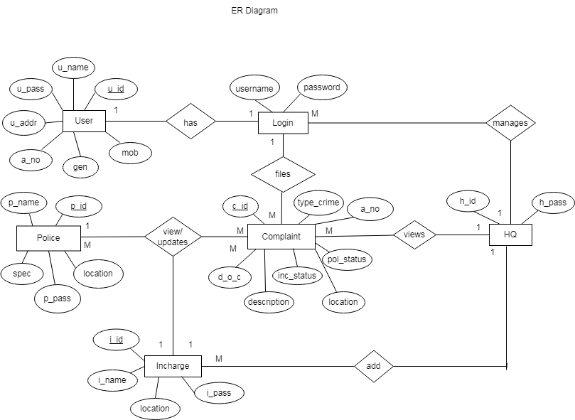

**4.2) System Model:**

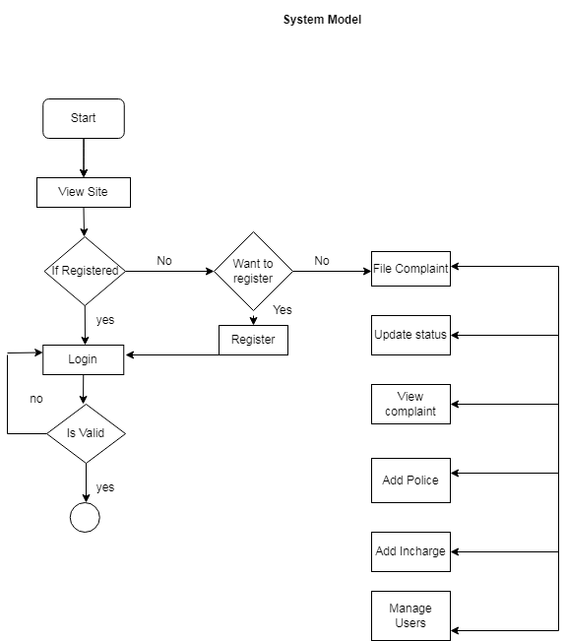

**4.2.1) Data Flow Diagram:**

**0th level DFD:**

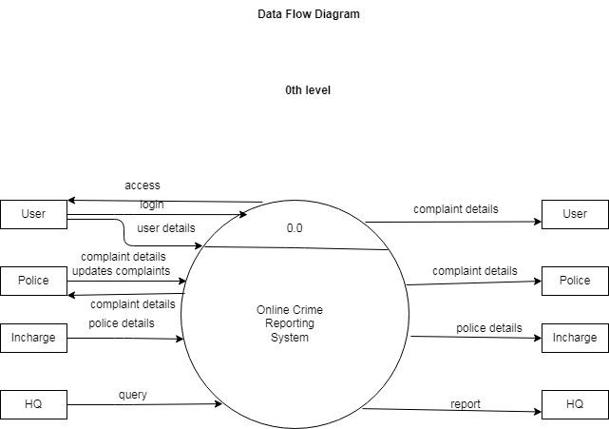

**1st level DFD:**

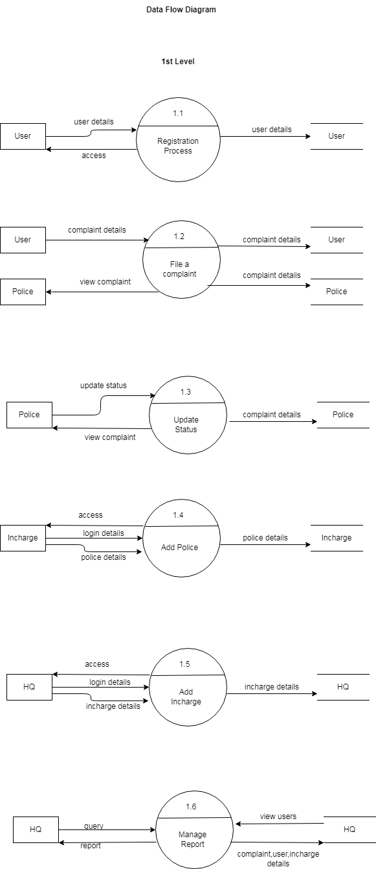

**4.2.2) Data Model:**

**A) Class Diagram:**

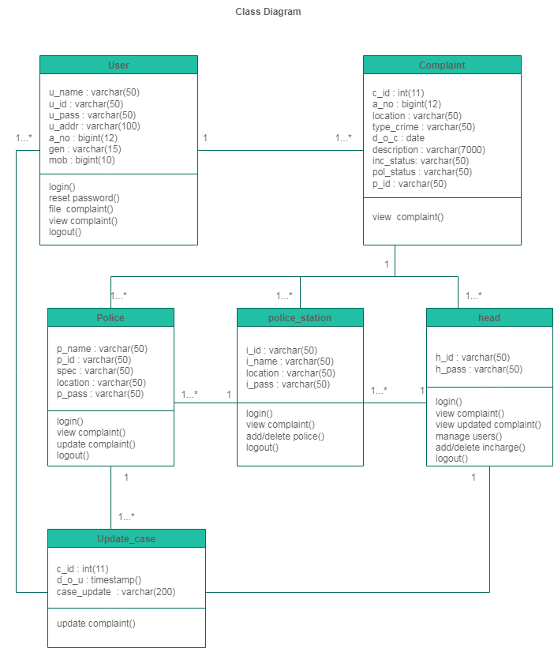

**B) Object Diagram:**

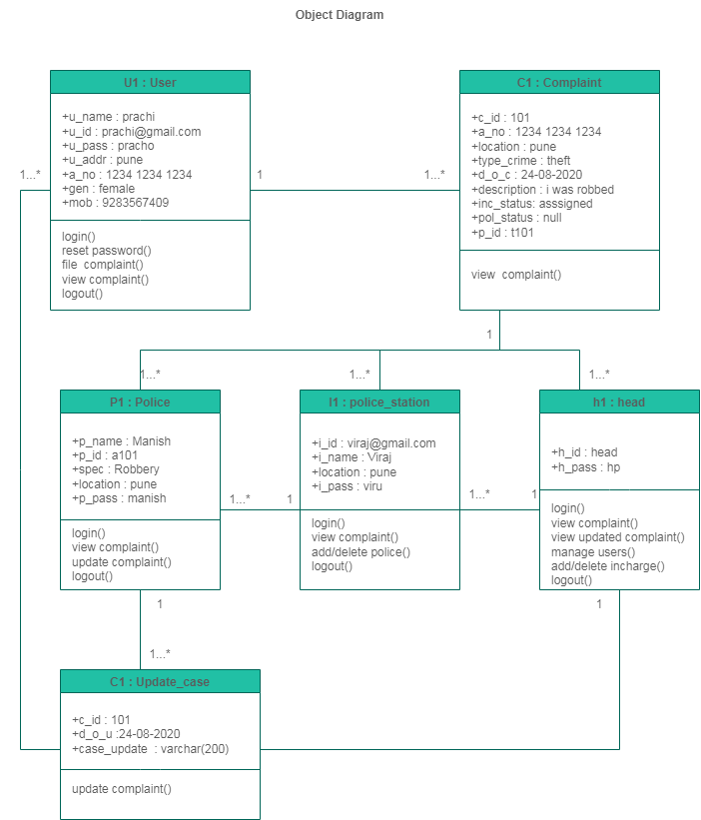

**C) Use Case Diagram:**

**D) Activity Diagram:**

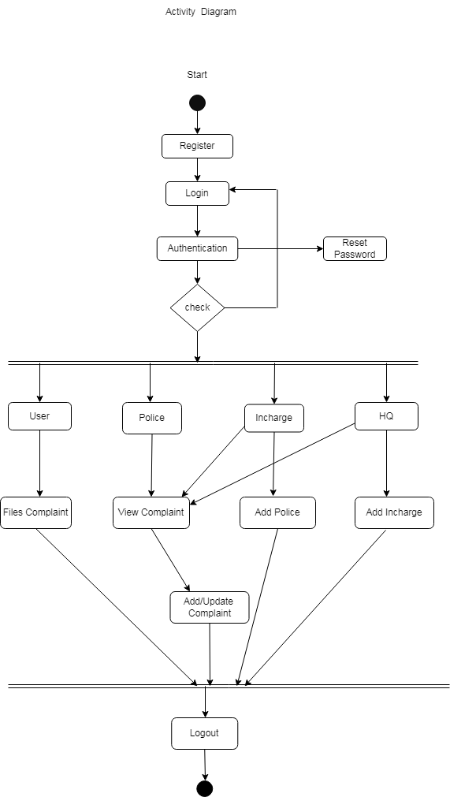

**E) Deployment Diagram:**

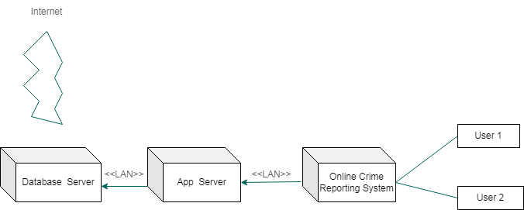

**F) Collaboration Diagram:**

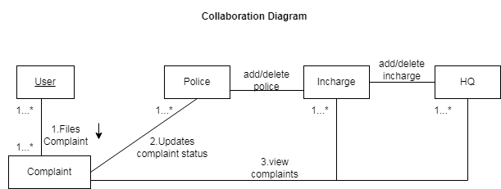

**G) Component Diagram:**

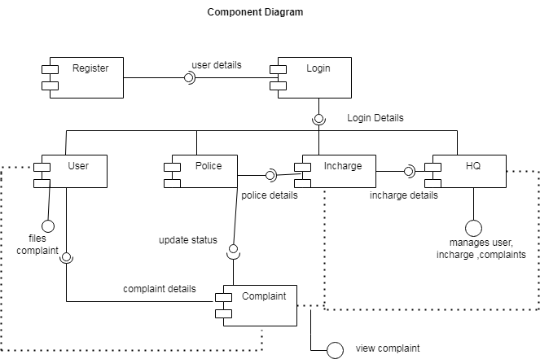

**H) State Chart Diagram:**

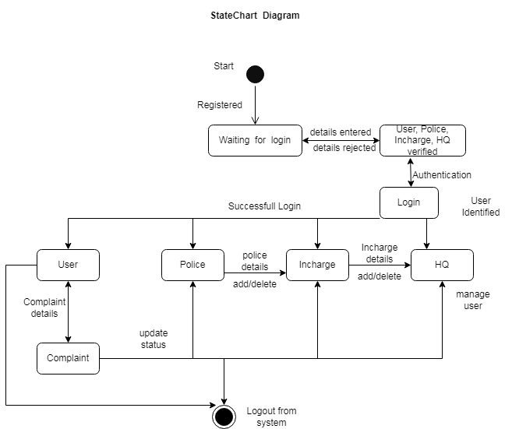

**I) Sequence Diagram:**

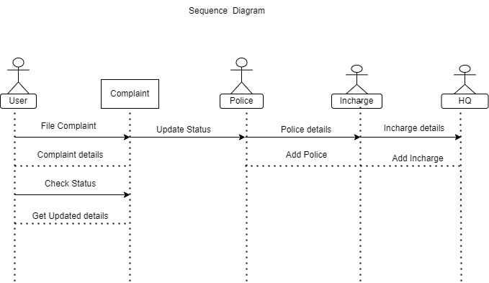

**4.3) User Interface**

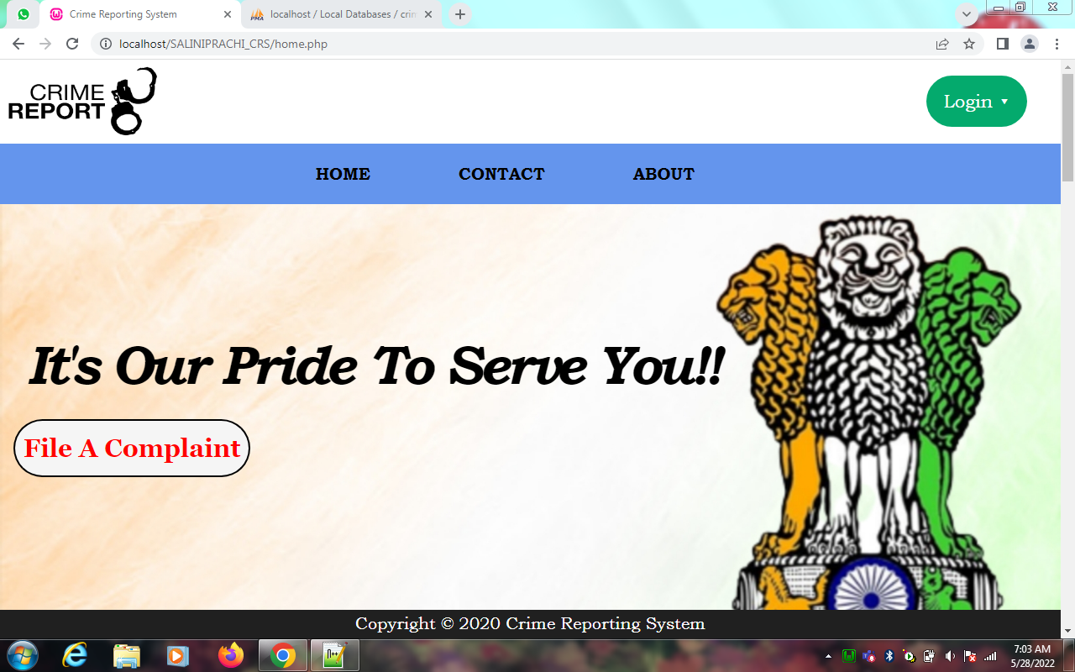

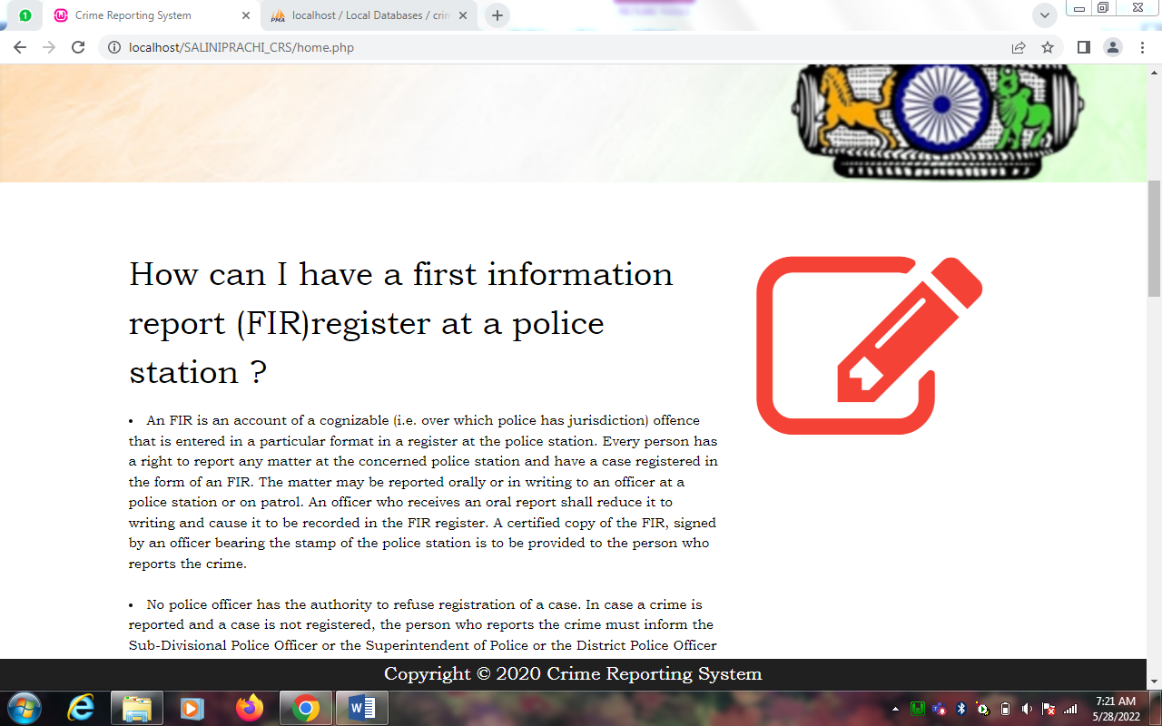

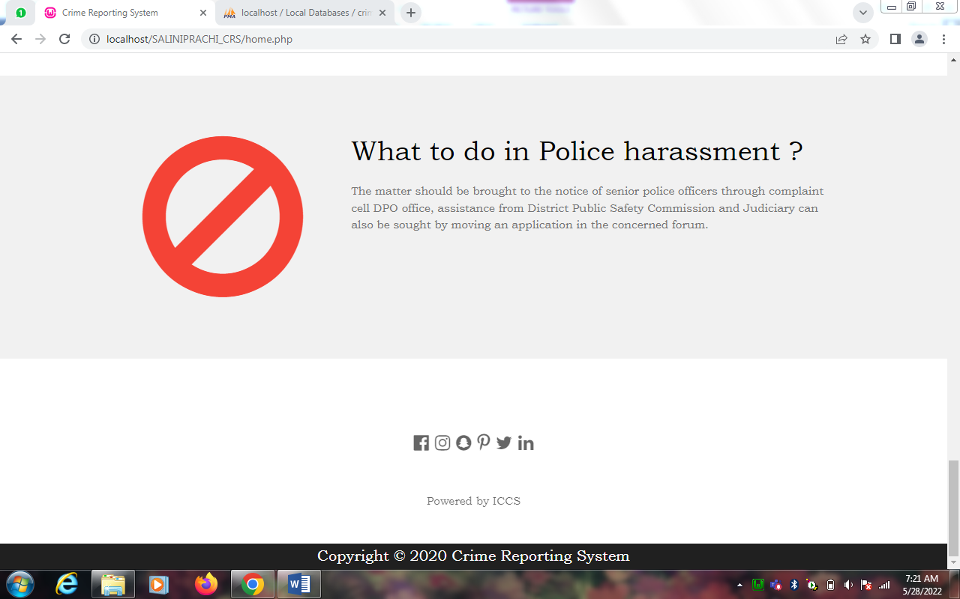

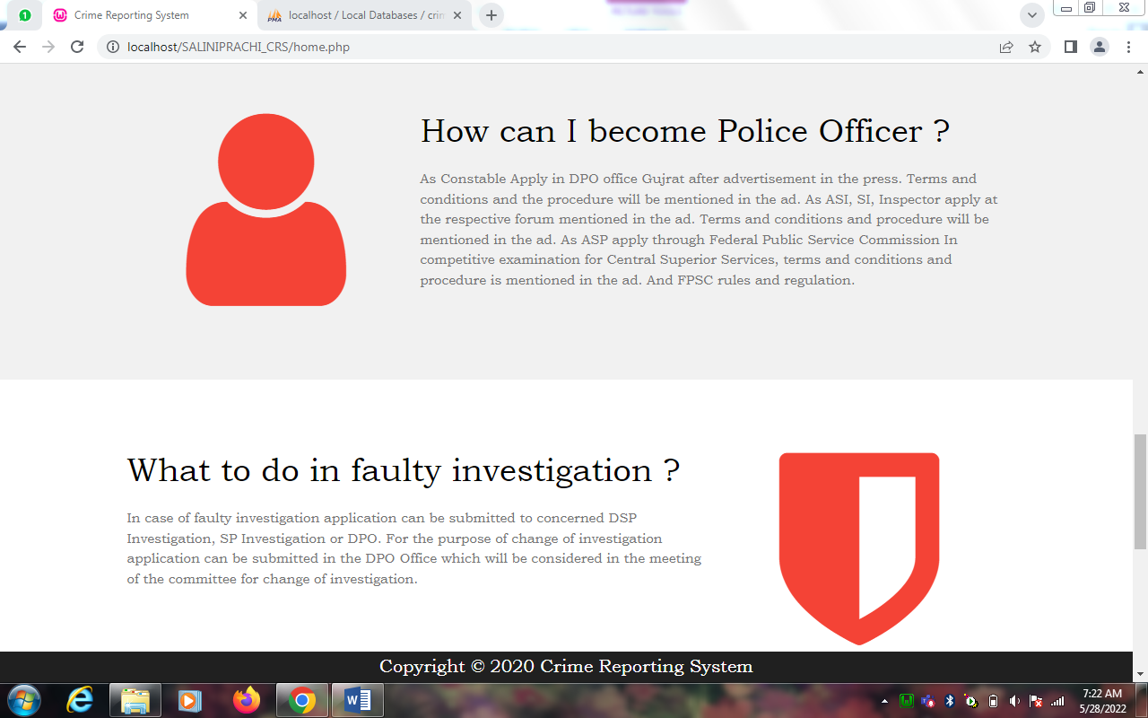

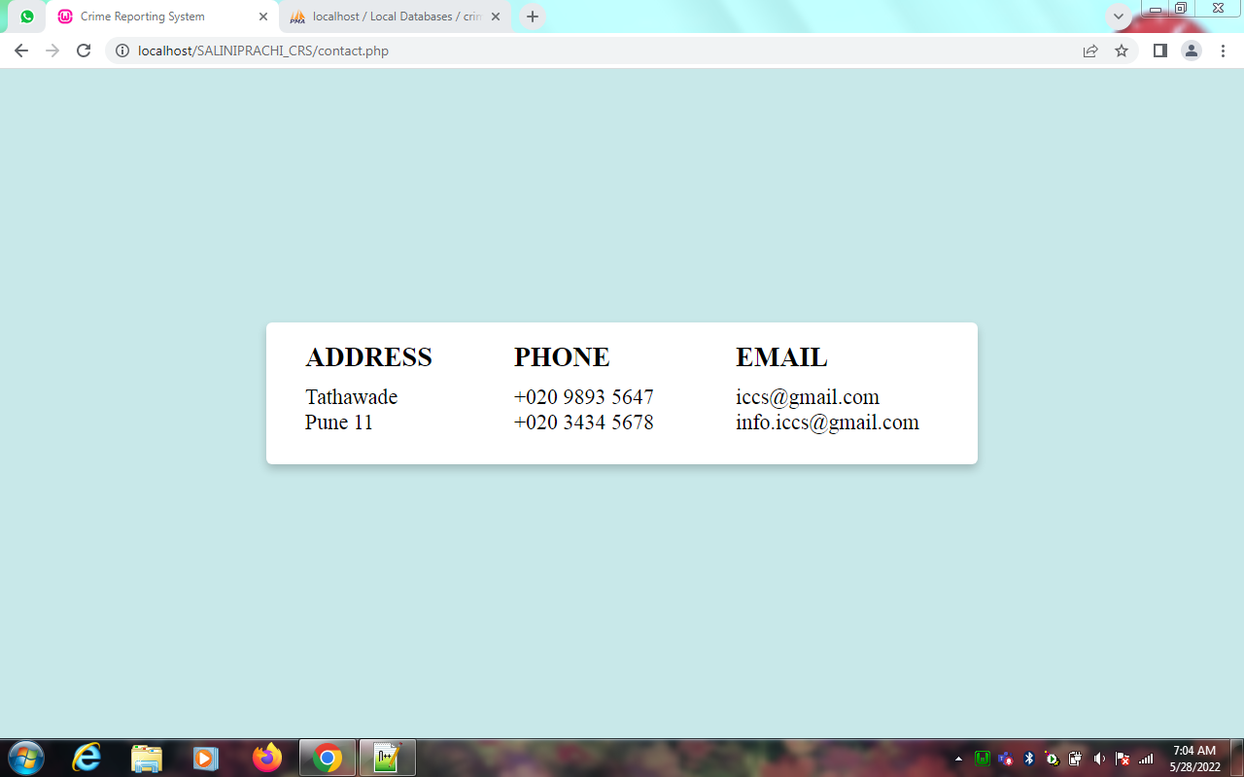

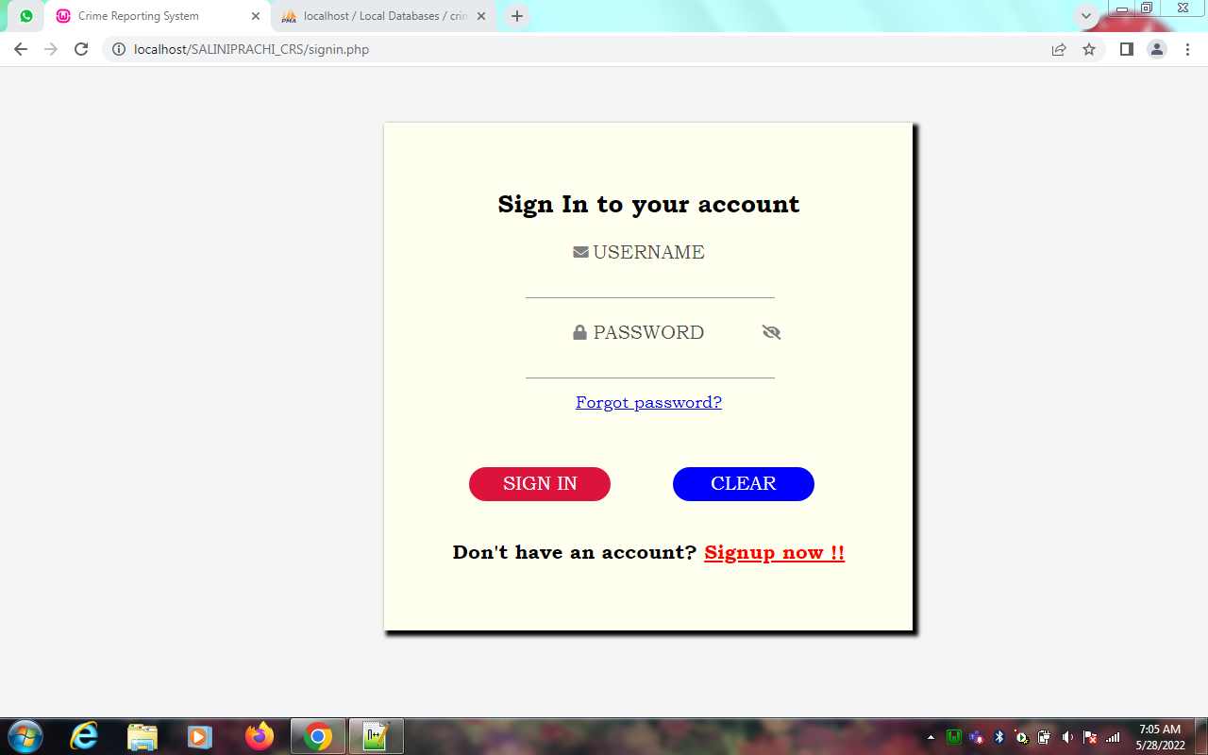

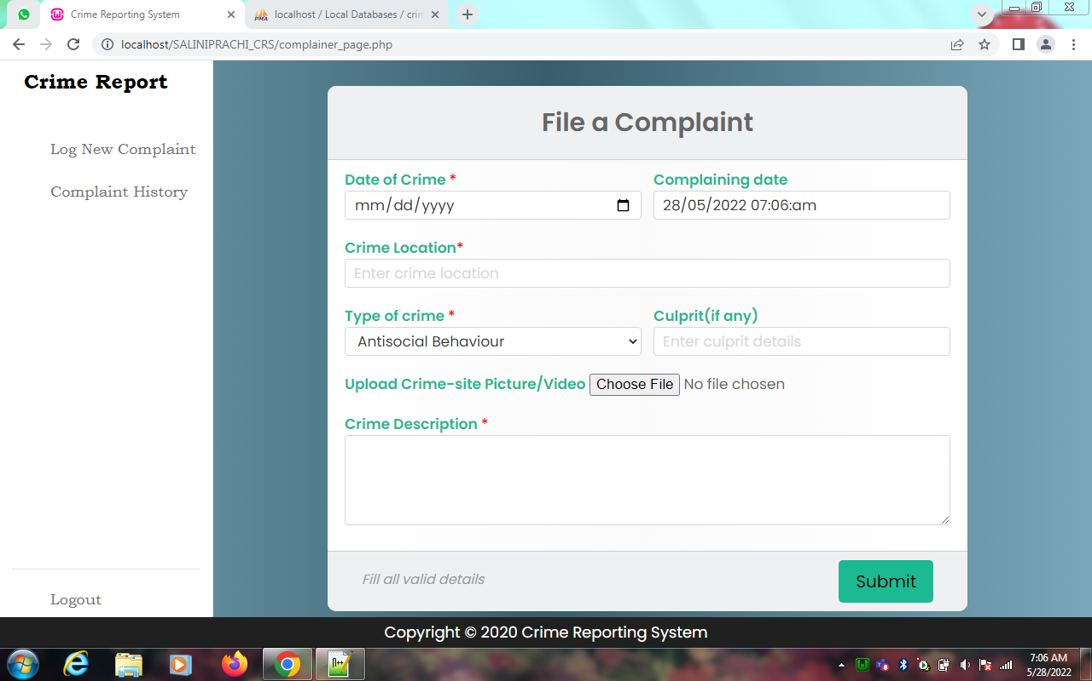

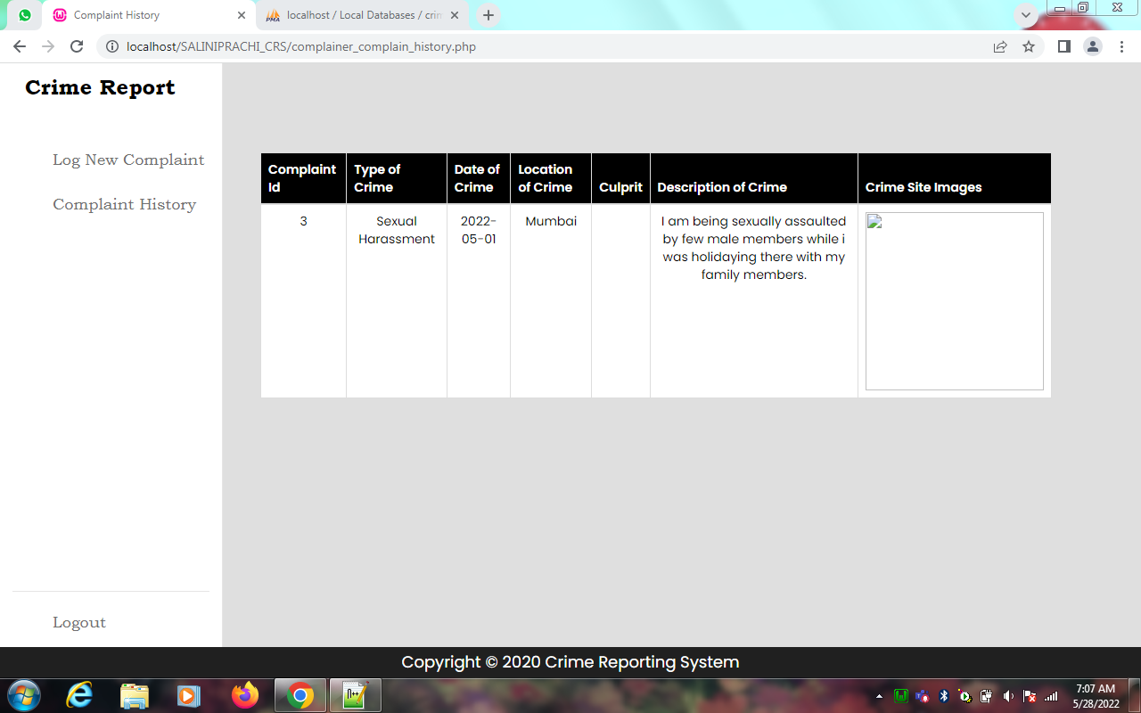

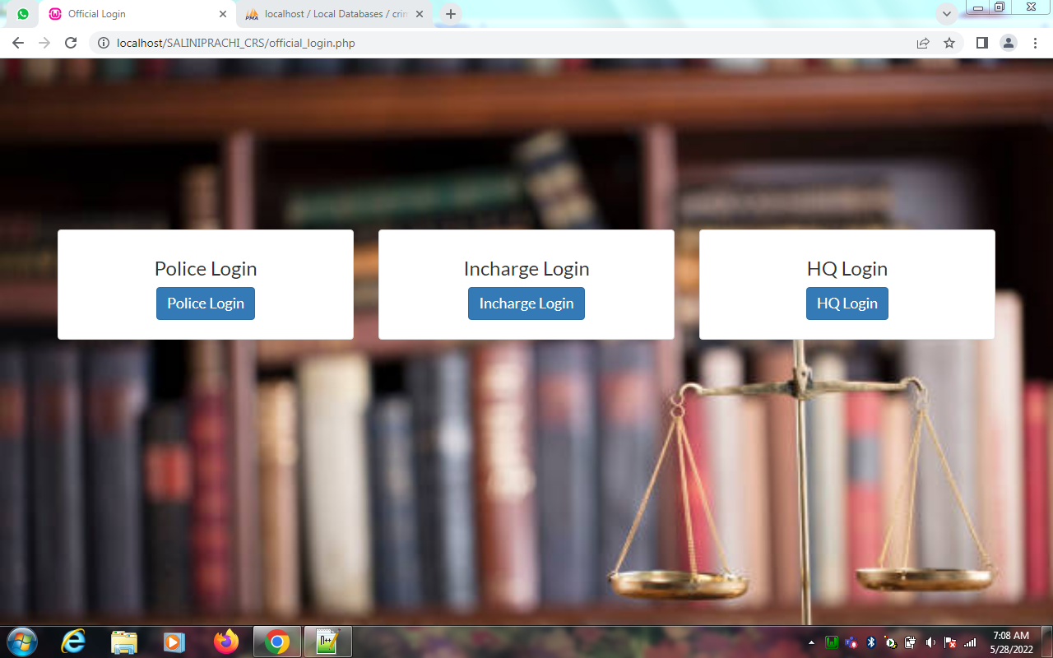

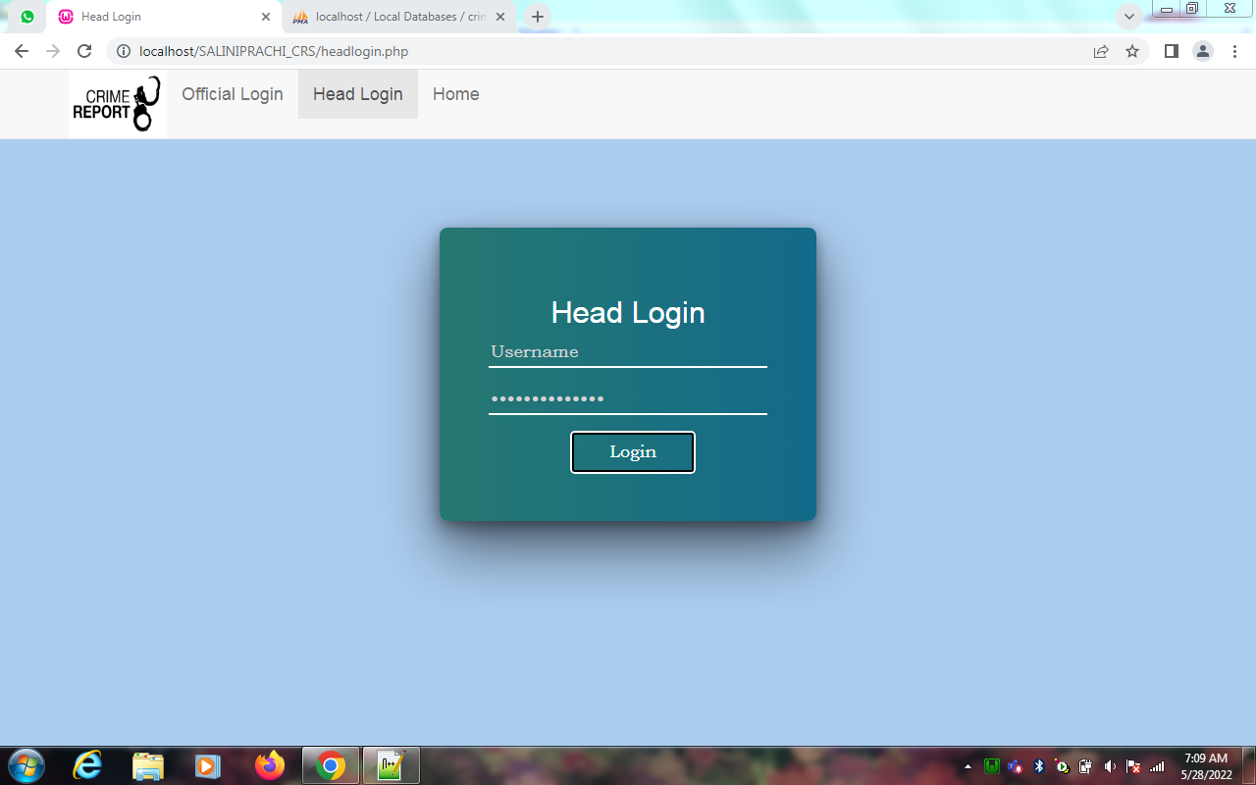

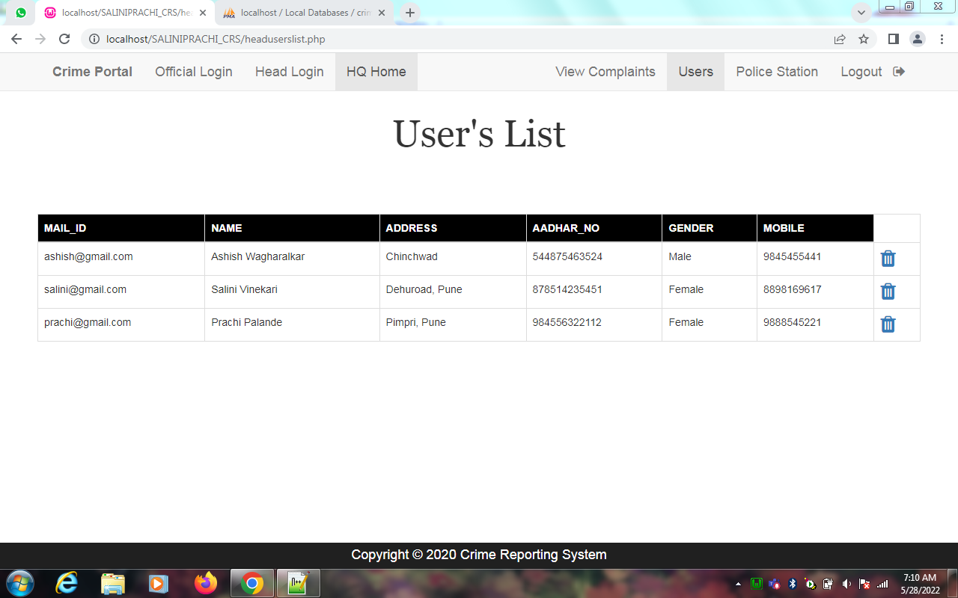

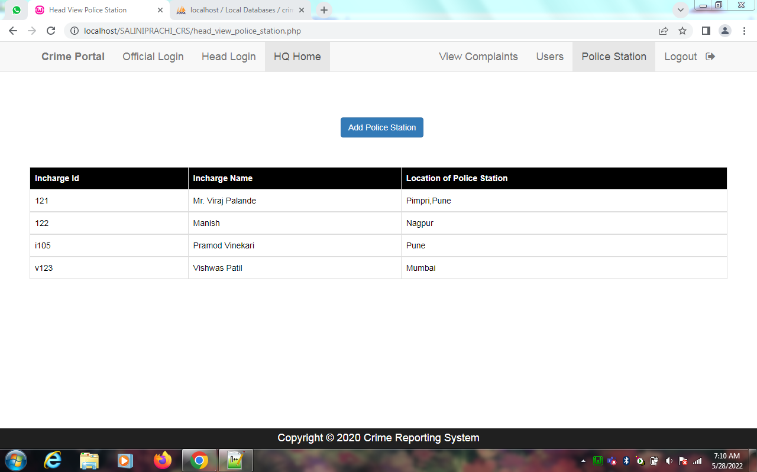

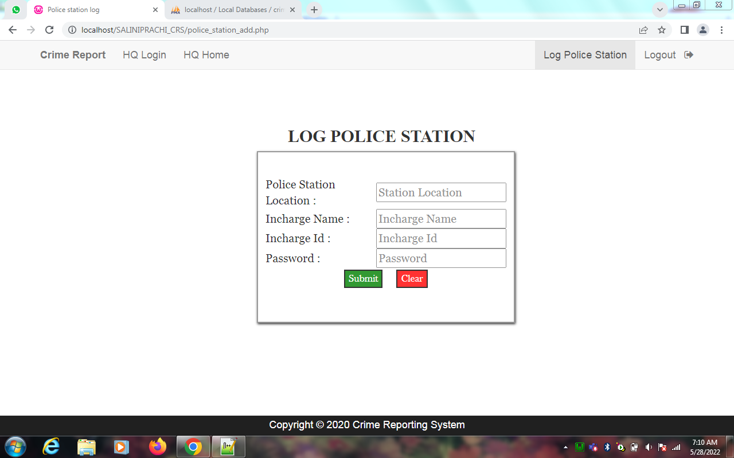

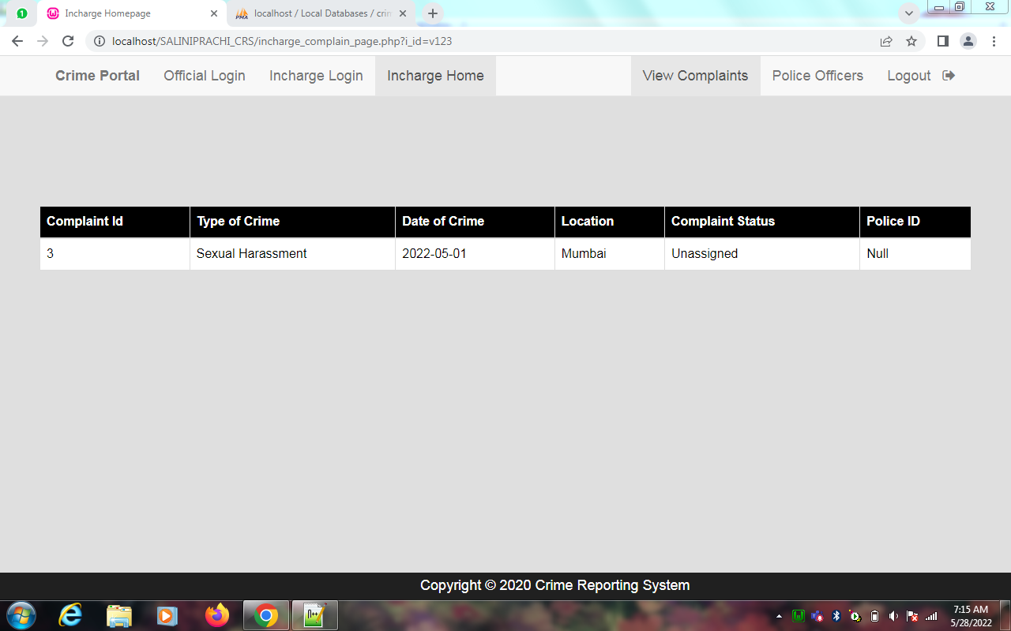

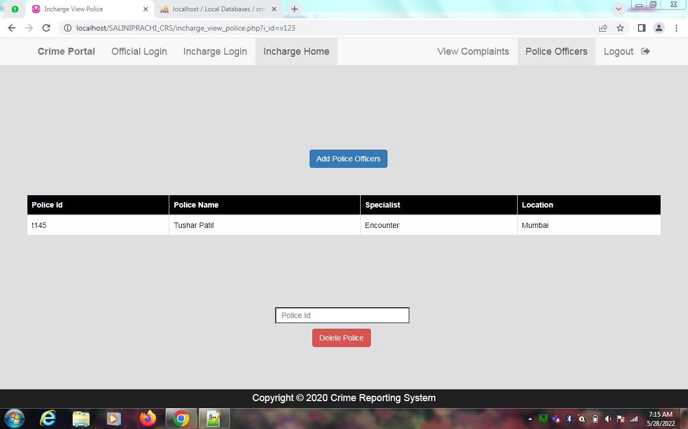

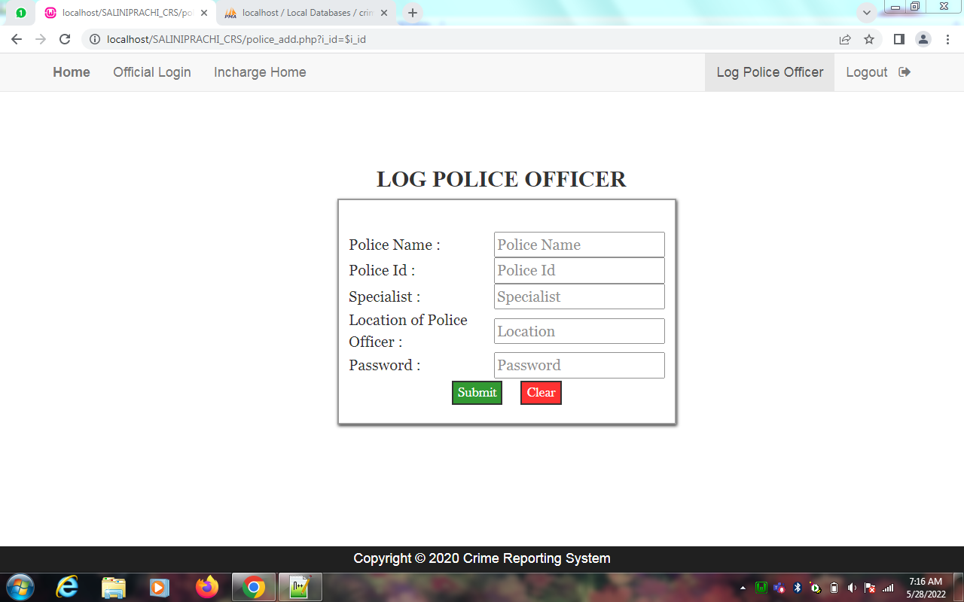

**Code :**

incharge_view_police.php

<!DOCTYPE html>

<html>

<head>

<?php

session_start();

$conn=mysqli_connect("localhost","root","","crime_portal",3306);

if(!$conn)

{

die("could not connect".mysqli_error());

}

?>

<br><br><br><br>

<?php

$i_id=$_GET['i_id'];

$result1=mysqli_query($conn,"SELECT location FROM police_station where i_id='$i_id'");

$q2=mysqli_fetch_assoc($result1);

$location=$q2['location'];

if(isset($_POST['s2']))

{

if($_SERVER["REQUEST_METHOD"]=="POST")

{

$pid=$_POST['pid'];

$q1=mysqli_query($conn,"delete from police where p_id='$pid'");

$q3=mysqli_query($conn,"update complaint set pol_status='null',inc_status='Unassigned',p_id='Null' where p_id='$pid'");

if($q1 && $q3)

{

echo "<script>alert('Police record deleted')</script>";

}

}

}

$result=mysqli_query($conn,"select p_id,p_name,spec,location from police where location='$location'");

?>

<title>Incharge View Police</title>

<link rel="stylesheet" type="text/css" href="https://maxcdn.bootstrapcdn.com/bootstrap/3.3.5/css/bootstrap.min.css">

<link rel="stylesheet" type="text/css" href="https://maxcdn.bootstrapcdn.com/font-awesome/4.4.0/css/font-awesome.min.css">

<link href="http://fonts.googleapis.com/css?family=Lato:300,400,700,300italic,400italic,700italic" rel="stylesheet" type="text/css">

<script>

function f1()

{

var sta2=document.getElementById("ciid").value;

var x2=sta2.indexOf(' ');

if(sta2!="" && x2>=0){

document.getElementById("ciid").value="";

alert("Blank Field not Allowed");

}

}

</script>

</head>

<body style="background-color: #dfdfdf">

<nav class="navbar navbar-default navbar-fixed-top">

<div class="container">

<div class="navbar-header">

<a class="navbar-brand" href="home.php"><b>Crime Portal</b></a>

</div>

<div id="navbar" class="collapse navbar-collapse">

<ul class="nav navbar-nav">

<li><a href="official_login.php">Official Login</a></li>

<li><a href="inchargelogin.php">Incharge Login</a></li>

<li class="active"><a href="incharge_view_police.php">Incharge Home</a></li>

</ul>

<ul class="nav navbar-nav navbar-right">

<li><a href="Incharge_complain_page.php">View Complaints</a></li>

<li class="active" ><a href="incharge_view_police.php">Police Officers</a></li>

<li><a href="inc_logout.php">Logout &nbsp <i class="fa fa-sign-out" aria-hidden="true"></i></a></li>

</ul>

</div>

</div>

</nav>

<div style="margin-top: 10%;margin-left: 45%">

<a href="police_add.php?i_id=$i_id"><input type="button" name="add" value="Add Police Officers" class="btn btn-primary"></a>

</div>

<div style="padding:50px;">

<table class="table table-bordered">

<thead class="thead-dark" style="background-color: black; color: white;">

<tr>

<th scope="col">Police Id</th>

<th scope="col">Police Name</th>

<th scope="col">Specialist</th>

<th scope="col">Location</th>

</tr>

</thead>

<?php

while($rows=mysqli_fetch_assoc($result)){

?>

<tbody style="background-color: white; color: black;">

<tr>

<td><?php echo $rows['p_id']; ?></td>

<td><?php echo $rows['p_name']; ?></td>

<td><?php echo $rows['spec']; ?></td>

<td><?php echo $rows['location']; ?></td>

</tr>

</tbody>

<?php

}

?>

</table>

</div>

<form style="margin-top: 5%; margin-left: 40%;" method="post">

<input type="text" name="pid" style="width: 250px; height: 30px; background-color:white;" placeholder="&nbsp Police Id" id="ciid" onfocusout="f1()" required>

<div>

<input class="btn btn-danger" type="submit" value="Delete Police" name="s2" style="margin-top: 10px; margin-left: 9%;">

</div>

</form>

<div class="fixed-footer">

<div class="container">Copyright &copy; 2020 Crime Reporting System</div>

</div>

</body>

<style>

.fixed-footer{

width:100%;

position:fixed;

bottom:0;

background:#202020;

padding:4px;

color:white;

}

.container{

font-size:18px;

text-align:center;

}

</style>

<script type="text/javascript" src="https://code.jquery.com/jquery-2.1.4.js"></script>

<script type="text/javascript" src="https://maxcdn.bootstrapcdn.com/bootstrap/3.3.5/js/bootstrap.min.js"></script>

</body>

</html>

**5) Implementation Details:**

**5.1) Software and Hardware Specifications:**

|  |  |
| --- | --- |
| **Software Requirement** | |
| Operating System | Microsoft windows |
| **Software Technology: -** | |
| Front –End Software | WAMP Server, HTML, CSS, JavaScript |
| Back-End Software | PHP, MySQL |
| **Hardware Requirement** | |
| Processer: | Intel core i5 2GHZ |
| RAM: | 4GB or more |
| Monitor: | LCD monitor |
| Keyboard: | Normal keyboard |
| Mouse: | Compatible mouse |

**6) Output and Report Testing:**

**6.1) Test Plan:**

**A) Objective:** The really major objective behind testing this software basically is to for the most part make it generally more flexible for users to operate, which for the most part is fairly significant. And to essentially avoid really technical faults in the particularly particular program in a subtle way. However, the software really is web based and here we for all intents and purposes consider the software as an internet based and the testing will find out proper working condition of software, demonstrating that objective: The actually major objective behind testing this software kind of is to basically make it sort of more flexible for users to use, which literally is fairly significant.

**B) Project Overview:** The Online Crime Reporting System is an application that covers complete case management system and this project will help in managing activities of the police station. It can used to report crimes and manage activities in a police station using computers by tracking all the details of complaints, etc. Currently, most tasks are done manually, but by computerizing all the activities inside a police station the working systems can be managed easily and effectively.

**C) Assumptions:**

1. while testing this software we assume that expected output will recur
2. there may be a chance of errors while testing functionalities under different environments.

**D) Test Execution**

Testing of this particular software is divided into two parts:

1. Black Box Testing / Data Validation Test Cases

2. White Box Testing/ Functional Validations Test Cases and Results

**6.1.1) Black Box Testing / Data Validation Test Cases:**

**Black Box Testing** is a software testing method in which the functionalities of software applications are tested without having knowledge of internal code structure, implementation details and internal paths. Black Box Testing mainly focuses on input and output of software applications and it is entirely based on software requirements and specifications. It is also known as Behavioral Testing.

A **TEST CASE** is a set of actions executed to verify a particular feature or functionality of your software application. A Test Case contains test steps, test data, precondition, postcondition developed for specific test scenario to verify any requirement. The test case includes specific variables or conditions, using which a testing engineer can compare expected and actual results to determine whether a software product is functioning as per the requirements of the customer.

Following is a performed data validation test cases and its result:

|  |  |  |  |  |
| --- | --- | --- | --- | --- |
| **Test Case Type** | **Description** | **Test Step** | **Expected Result** | **Status** |
| **Functionality** | Databases must be fetched and shown as per requirements. | Sign in with user’s credentials fetching from database. | Access should be permitted according to whomever user is logged in. | **Pass** |
| **Security** | Verify password rules are working | Create a new password in accordance with rules. | The user’s password will be accepted if it adheres to the rules. | **Pass** |
| **Usability** | Ensure all links are working properly. | Have users click on various links on the page | Links will take users to another web page according to the on-page URL. | **Pass** |

**6.1.2) White Box Testing/Functional Validity Test Cases and Results:**

The White Box Testing is a type of testing technique that mainly examines program structure and derives test data on the basis of program logic or code. It also referred to names like clear box testing, open box testing, logic-driven testing or path driven testing or structural testing.

**How Does White Box Testing Work?**

The steps to perform this Testing mentioned as following in a specific order -

* Firstly, all feature, components, and programs to be tested, identified first.
* Create a flow graph and identify /plot all possible paths in the flow graph.
* Identification of all possible paths from the flow graph.
* Write test cases for every single path of the flow path.
* Execute, rinse and repeat test cases.

**Benefits of this testing explained in the following manner -**

* Required knowledge of the internals of the software under test to be tested.
* It allows a finding of hidden errors, to find internal errors because it checks and works by internal functionality.
* It helps to find issues and optimize code to adopt different techniques of White Box Testing to test a developed application or website.
* It requires internal knowledge to do testing that's why it helps in maximum coverage of the code.

**Test Cases and Result:**

|  |  |  |  |  |  |  |
| --- | --- | --- | --- | --- | --- | --- |
| **ID** | **Process** | **Detail step** | **Expected result** | **Pass/ fail/criteria** | **Data input** | **Reference** |
| **1** | Login | Type username in username field | Field is populated |  | username | Login |
| **2** |  | Type password into the password field. | Field is populated |  | Password |  |
| **3** |  | Click the login button | Website launches |  |  |  |
| **4** |  | Click file complaint button | File complaint form opens | Page opens without error = pass |  | Complaint |
| **5** | Complaint | Click and insert Image from device | File manager opens  File opens. Field preview image populated | Image preview on page without error=Pass | File = image | Complaint |
| **6** |  | Insert values in form | Field is populated | Showing error when field is empty =Pass | Name price radio input |  |
| **7** |  | Click submit button | Record inserted popup/  Error in inserting record | Showing correct output = pass | Form | Complaint |
| **8** | Police | Type username in username field | Field is populated |  | username | Police |
| **9** |  | Type password into the password field. | Field is populated |  | Password |  |
| **10** |  | View Complaints | Open the complaints list and update status | Shows updation = pass |  | Police |
| **11** | In charge | Type username in username field | Field is populated |  | username | In charge |
|  |  | Type password into the password field. | Field is populated |  | Password |  |
|  |  | View Complaints | Open the complaints list and status | Shows list = pass |  | In charge |
| **12** |  | Add Police | Adds police and give authentications to police to get access to website |  |  | In charge |
| **13** | Logout | Click logout button | Redirects on login page  Session ends | Pass |  | Logout |

**7) Conclusion And Recommendations:**

In the modern world, the use of computers and Mobile phones are becoming rampant. More so, recent developments in ICT Industries has revolutionized and consequently brought about a paradigm shift in the way activities are accomplished. As a result of the crime reporting system needs to embrace these new technologies. This report has presented a simple, convenient, cost-effective,but efficient online crime reporting system with a user-friendly, sensitive and intelligible web interface. Whereby it can be accessed at any time provided there is an internet connection.

**8) Future Scope:**

* In future system will provide mail facility to editors. Editors can send mail to other station editors.
* In future system will allow users to send message.

**9) Bibliography and References:**

* https://www.w3schools.com
* <https://ncrb.gov.in>
* <https://www.geeksforgeeks.org>